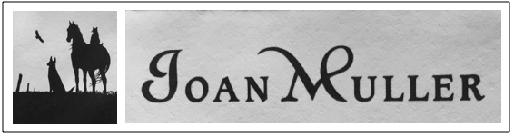

161 New Sweden Rd.
Woodstock, CT 06281
860-428-1563
wyndwords@gmail.com
hawkonsoar@aol.com

CURRICULUM VITAE

EDUCATION
- University of Connecticut, Connecticut Writing Project Fellowship, 2010
- Notre Dame College, “Picturing Writing: Fostering Literacy Through Art,” 2001
- Rhode Island School of Design, “The Art of Image,” 1998
- University of New Hampshire, Summer Institutes, “The New Hampshire Writing Program,” and “The Art of Image Making,” 1999, 2000
- Hartford Art School of the University of Hartford, BFA, 1974
- Academic Oil Painting apprenticeship with Professor Nikolai Malyschkyn, U of St. Petersburg, 1965-1968
ART EXHIBITS AND WORKSHOPS
- The Berkshire Museum, Berkshire Art Association, juried exhibition1975
- Wadsworth Atheneum, Connecticut Academy of Fine Arts Bicentennial Exhibit, juried exhibition 1976, McCook Memorial Prize
- Gallery on the Green, Canton, CT, juried exhibition1976
- Kentucky Horse Park, Lexington, KY, The American Academy of Equine Art Exhibit, juried exhibition1995
- Lexington, KY, Harness Tracks of America Association Art Show, juried exhibition 1995
- Ch 14 documentary: “Profile of the Artist, Joan Muller.” 1996
- Joseloff Gallery, West Hartford, “Small Works Exhibit,” juried exhibition 2006
- Woodstock, CT, “Artist’s Collaborative,” 2006
- Hampton, CT, “Opening Your Sk-eyes,” Watercolor workshop leader
ORGANIZATIONS, MEMBERSHIPS AND PROFESSIONAL ASSOCIATIONS
- State of CT Licensed Wildlife Rehabilitator
- State of CT PreK-12 Art Teacher
- Society of Scribes
- The Hampton Writing Circle (founder)
- Brotherhood of Carpenters and Joiners
- Academic Artists Association, Inc. Springfield, MA 1965-1968
BUSINESS
- Sole proprietor of Joan Muller Illustration and Design since 1988 with national and international corporate and private clients.

